Water, intermolecular forces and Chromatography.

:

Section A Multiple choice (15 marks)

Section A consists of 15 questions, each worth one mark. Each question has only one correct answer. Circle the correct answer. Attempt all questions. Marks will not be deducted for incorrect answers. You are advised to spend no more than 15 minutes on this section.

1 What shape are water molecules?

A Linear

B Trigonal planar

C Bent

D Tetrahedral

2 Which of the following processes does not involve ‘breaking’ or ‘forming’ intermolecular bonds?

A Ice melting

B Evaporating water from a salt solution

C Decomposing water into hydrogen and oxygen

D Water droplets condensing on a cold mirror

3 Which of the following is the correct valence structure diagram for chlorine gas?

A 

B 

C 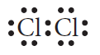

D 

4 A molecule with a tetrahedral shape is identified as having:

A 4 electron pairs and 0 lone pairs on the central atom.

B 3 electron pairs and 1 lone pair on the central atom.

C 4 electron pairs and 1 lone pair on the central atom.

D 4 electron pairs and 2 lone pairs on the central atom.

5 What is the maximum number of covalent bonds that a nitrogen atom can form?

A 3

B 2

C 1

D 0

6 In which of the following substances are bonding electrons shared evenly?

A Hydrogen chloride

B Water

C Ammonia

D Fluorine gas

7 The following all possess polar bonds, but which is a polar molecule?

A C2H4

B CCl4

C NH3

D CO2

8 The intermolecular forces in order of increasing strength are:

A dipole–dipole < dispersion < hydrogen bonds.

B dipole–dipole > dispersion > hydrogen bonds.

C dispersion < dipole–dipole < hydrogen bonds.

D dispersion > dipole–dipole > hydrogen bonds.

9 When bonded with a hydrogen atom, which of the following atoms does **not** form a hydrogen bond?

A Nitrogen

B Chlorine

C Oxygen

D Fluorine

10 Which of the following has the lowest boiling point?

A HF

B H2S

C HCl

D CH4

11 Which type of force or bond exists between all covalent molecular substances?

A Dispersion forces

B Dipole–dipole forces

C Hydrogen bonds

D Covalent bonds

12 Capillary action helps plants take up soluble nutrients from the soil. Which of these forces is not involved in capillary action?

A Surface tension

B Cohesive force

C Adhesive force

D Gravitational force

13 Ionic compounds that are referred to as hydrated:

A are ionic salts that can be dissolved in water.

B have waters of crystallisation attached.

C have had waters of crystallisation removed by heating.

D all contain hydrogen bonds between the ions and the water molecules surrounding them.

14 Surfactants:

A decrease the wettability of a liquid.

B interrupt the surface tension of water.

C are hydrophobic.

D are hydrophilic.

15 The type of chromatography used to analyse the presence of drugs or the pigment in plants is:

A gas chromatography.

B high-performance liquid chromatography.

C thin-layer chromatography.

D paper chromatography.

1. In a gas chromatograph
   1. the retardation factor indicates the identity of the substance.
   2. smaller particles have a longer retention time than larger particles.
   3. the retention time indicates the amount of the substance and the peak height indicates the identity of the substance present.
   4. the retention time indicates the identity of the substance and the area under the peak indicates the amount of the substance present.
2. In a mixture of alcohols, each component can be identified by HPLC. The alcohol with the longest retention time will be the one that:

a) is the most soluble in the mobile phase.

b) has the smaller molar mass.

c) will emerge first from the column.

d) adsorbs most strongly in the stationary phase.

18. Consider the following TLC plate of compounds X, Y and Z developed using   
 a non- polar mobile phase on a polar stationary phase.

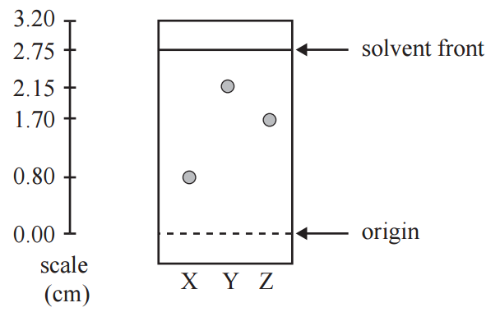

The Rf value of the most polar component in this TLC separation is:

* 1. 0.29
  2. 0.78
  3. 0.80
  4. 2.15

Section B Short answer (15 marks)

Section B consists of five questions. Write your answers in the spaces provided. You are advised to spend 20 minutes on this section.

1 Describe the three types of intermolecular force. (3 marks)

2 Caffeine is a stimulant drug that is found in coffee, tea, energy drinks and some soft drinks. The concentration of caffeine in drinks can be determined using HPLC.

Four caffeine standard solutions containing 50 ppm, 100 ppm, 150 ppm and 200 ppm were prepared. 25 μL of each sample was injected into the HPLC column. The peak areas were measured and used to construct the calibration graph below. The chromatograms of the standard solutions each produced a single peak at a retention time of 96 seconds.



25 μL samples of various drinks thought to contain caffeine were then separately passed through the HPLC column. The results are summarised below.

|  |  |  |
| --- | --- | --- |
| **Sample** | **Retention time of  major peak (seconds)** | **Peak area of largest peak** |
| Soft drink A | 96 | 12 000 |
| Soft drink B | 32 | 8 500 |

a) What is the concentration, in ppm, of caffeine in soft drink A? (1 mark)

_______________________________________________________________________



b) What evidence is presented in the chromatogram that supports the conclusion that soft drink B does not contain any caffeine? (1 mark)

_________________________________________________________________________

_________________________________________________________________________

(3 marks)

4 Use a labelled diagram to describe why ethanol is so useful as a solvent.   
 (3 marks)

5 Use a table to contrast gas chromatography and high-performance liquid chromatography. (3 marks)

End of test (30 marks)